Project Sprint #1

The Solitaire game is described in CS449HomeworkOverview. You should read the description very carefully.

In this assignment, you aim to specify the requirements (i.e., user stories and acceptance criteria) of the target software that allows a human player to play a Solitaire game. These requirements will be fully implemented by the end of sprint 3. The minimum features include choosing the board size and type, starting a new game, making a move, determining if a game is over. The following is a sample GUI layout.

Board size
Board Type  - English  - Hexagon  - Diamond | 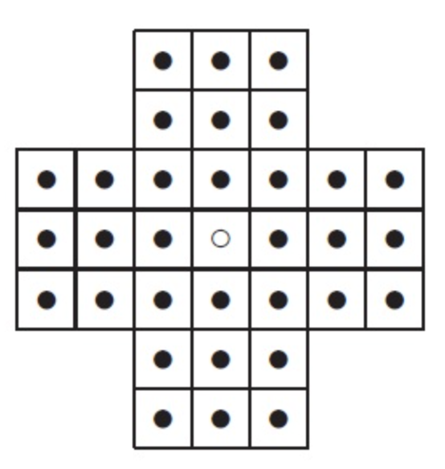
Figure 1. Sample GUI layout of the first working program by the end of Sprint 3

Use the following tables to document your user stories and acceptance criteria.

You are required to use the free ChatGPT or another LLM to complete two user stories and two of their respective acceptance criteria. You must ensure that the generated user stories are correct and fix them if not. At the end of the submission, provide screenshots of your LLM prompts and answers, along with the description of errors the LLM made that you had to correct. Points will be deducted if no screenshots/description are provided.

For the other user stories and acceptance criteria, you are not required to use LLM.

- User Stories (3 points)

- User Story Template: As a <role>, I want <goal> [so that <benefit>]

ID | User Story Name | User Story Description | Priority | Estimated effort (hours)
1 | Choose a board size | As a human player, I want to select a supported board size so that I can play Solitaire using my preferred board configuration. | High | ~7
2 | Choose the board type | As a human player, I want to choose between English, Hexagon and Diamond boards so that I can play Solitaire using my preferred board layout. | High | 3
3 | Start a new game of the chosen board size and type | As a human player, I want to start a new game with my selected board size and type so that I can begin playing with a correctly initialized board. | High | 5
4 | Make a move in a game | As a player, I want to jump one peg over an adjacent peg into an empty hole, so that I can remove pegs from the board and work toward solving the puzzle. | High | 14
5 | A game is over | As a human player, I want the game to automatically detect when I have won or when no valid moves remain so that I know the game has ended and can see my performance rating. | High | 5

- Acceptance Criteria (AC) (12 points): Add/delete rows as needed.

User Story ID and Name | AC  ID | Description of Acceptance Criterion | Status (completed, toDo, inPprogress)
1. Choose a board size | 1.1 | AC 1.1 -Default board size  Given the player launches the application for the first time,  When the game displays the configuration screen,  Then the default board size is set to 7. | toDO
1. Choose a board size | 1.2 | AC 1.2 - Select a supported board size  Given the player is on the game's configuration screen,  When the player selects a supported board size  Then the game saves the selected size for the next game. | toDO
1. Choose a board size | 1.3 | AC 1.3 - Apply the selected board size  Given the player has selected a supported board size and board type,  When the player starts a new game,  Then the game initializes and displays a board using the selected size and type. | toDO
1. Choose a board size | 1.4 | AC 1.4 - Reject an unsupported board size  Given the player is configuring a new game,  When the player attempts to enter an unsupported board size,  Then the game rejects the selection and keeps the previous valid size. | toDO
2. Choose the board type | 2.1 | AC 2.1 - Select a board type  Given the player is on the game's configuration screen,  When the player selects English, Hexagon or Diamond,  Then the game saves the selected board type. | toDO
2. Choose the board type | 2.2 | AC 2.2 - Apply the selected board type  Given the player has selected a supported board type and size,  When the player starts a new game,  Then the game displays the selected board layout. | toDO
2. Choose the board type | 2.3 | AC 2.3 - Change the selected board type  Given the player has already selected a board type,  When the player selects a different board type before starting a game,  Then the game updates the selection to the newly chosen type. | toDO
3. Start a new game of the chosen board size and type | 3.1 | AC 3.1 - Initialize a new game  Given the player has selected a supported board size and type,  When the player clicks the New Game button,  Then the game initializes and displays the selected board with every valid position occupied by a peg except the central hole. | toDO
3. Start a new game of the chosen board size and type | 3.2 | AC 3.2 - Reset an existing game  Given a game is already in progress,  When the player starts a new game,  Then the current game is reset and the board is initialized using the selected board size and type. | toDO
4. Make a move in a game | 4.1 | AC 4.1 - Valid move  Given a game in progress where a peg has a peg directly adjacent to it and an empty hole directly beyond that peg in the same straight line  When the player selects that peg and then selects the empty hole  Then the selected peg moves to the empty hole, the jumped peg is removed from the board, and the original hole becomes empty. | toDO
4. Make a move in a game | 4.2 | AC 4.2 - Invalid move: landing hole occupied  Given a game in progress where a peg is adjacent to another peg, but the hole beyond it is occupied  When the player selects the first peg and then selects the occupied hole  Then no peg moves or is removed, the board state is unchanged, and the game indicates the move is not allowed. | toDO
4. Make a move in a game | 4.3 | AC 4.3 - AC 4.3 - Valid diagonal move  Given a game is in progress, with a peg that can jump diagonally over an adjacent peg into an empty, valid position two spaces away,  When the player selects the first peg and then selects the empty destination,  Then the game moves the selected peg to the destination, removes the jumped peg, and leaves the original position empty. | toDO
4. Make a move in a game | 4.4 | AC 4.4 - Invalid move: no peg to jump  Given a game in progress where a peg has an empty hole two spaces away in a straight line, but the hole between them is also empty  When the player tries to move the peg to the far empty hole  Then the move is rejected and the board state is unchanged. | toDO
4. Make a move in a game | 4.5 | AC 4.5 - Peg count updates  Given a game in progress with N pegs on the board  When the player completes a valid move  Then the board contains exactly N − 1 pegs, and any displayed peg count reflects this. | toDO
4. Make a move in a game | 4.6 | AC 4.6 - Selection feedback  Given a game in progress  When the player selects a peg that has at least one legal move  Then the peg is visibly highlighted, and the valid landing holes are indicated. | toDO
5. A game is over | 5.1 | AC 5.1 - Detect a successful game  Given a game is in progress,  When a valid move leaves exactly one peg remaining,  Then the game ends and displays an Outstanding performance rating. | toDO
5. A game is over | 5.2 | AC 5.2 - Detect when no valid moves remain  Given a game is in progress and more than one peg remains,  When the game determines that no valid moves are available,  Then the game ends automatically. | toDO
5. A game is over | 5.3 | AC 5.3 - Display the player's performance rating  Given the game has ended,  When the final number of remaining pegs is evaluated,  Then the game displays the appropriate performance rating according to the following rules:  Remaining pegs - Performance rating  1 - Outstanding  2 - Very Good  3 - Good  4 or more - Average | toDO
5. A game is over | 5.4 | AC 5.4 - Prevent moves after the game ends  Given the game has ended,  When the player attempts to make another move,  Then the game rejects the move and keeps the board unchanged. | toDO

LLM Documentation:
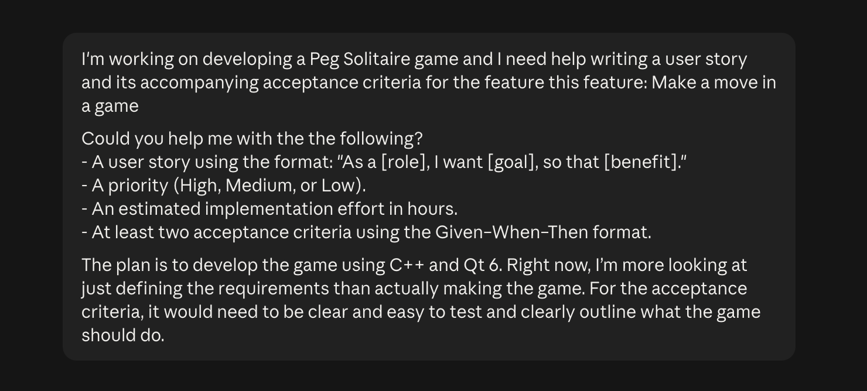

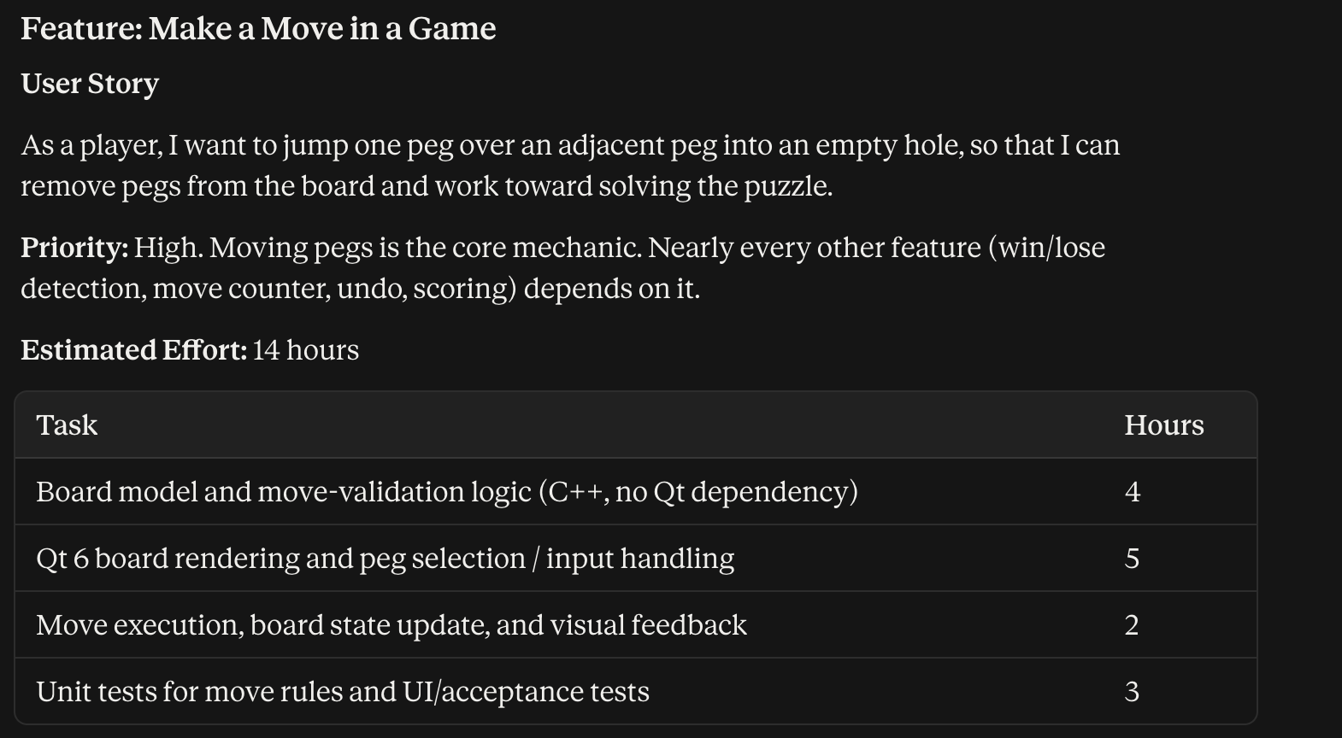
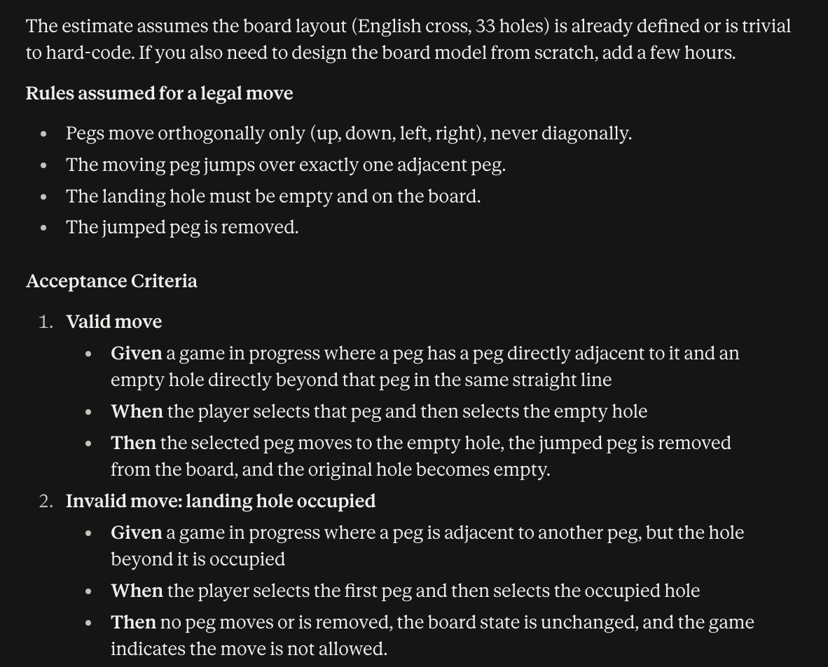

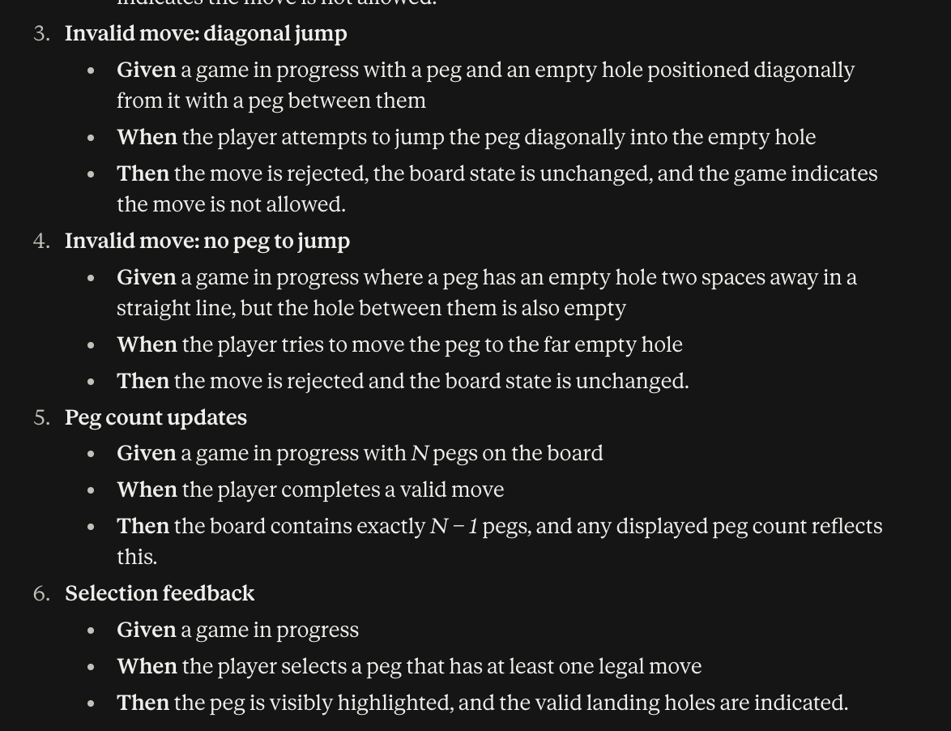

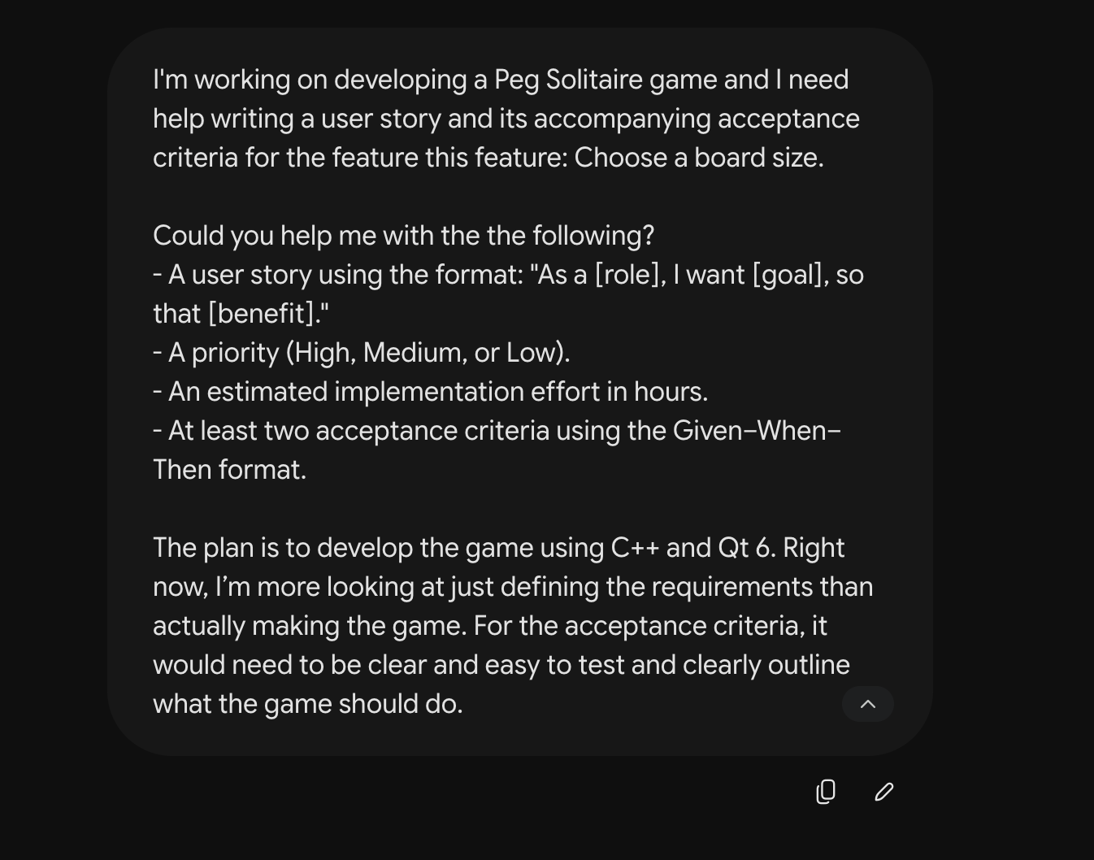
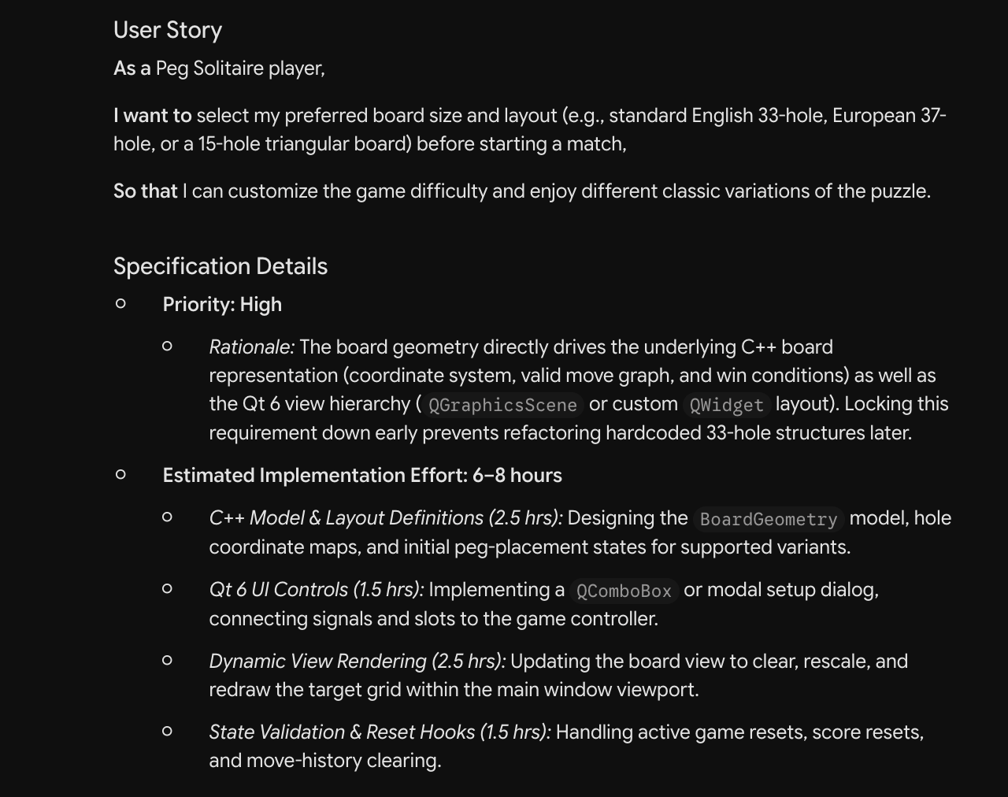

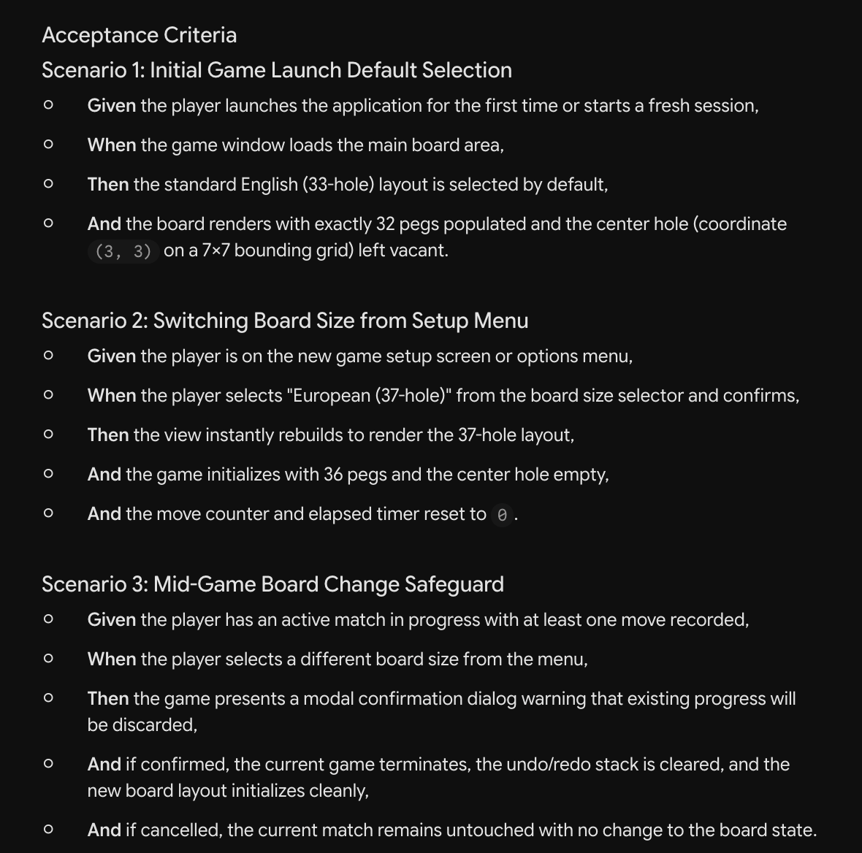

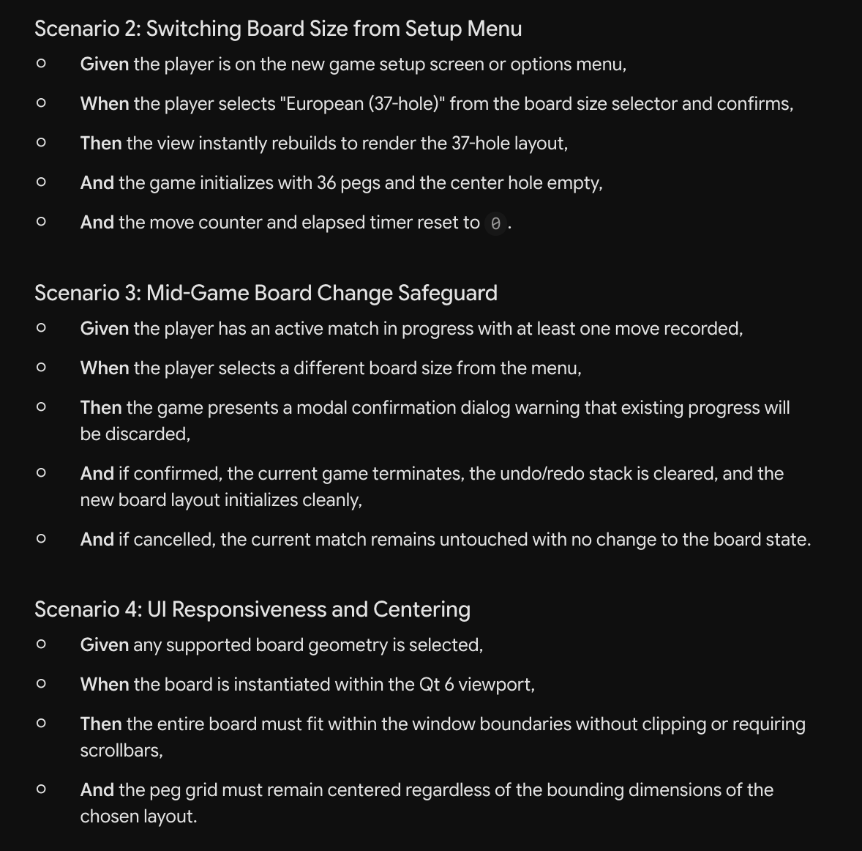

LLM Output Review and Corrections
I used an LLM to generate user stories 1 and 4, and their accompanying acceptance criteria. While reviewing them, I did notice there were two errors. For the first user story, the LLM was confused about the board size with board type and started suggesting English, European, and triangular board variations. So I just revised the story to focus on supported board size while keeping the required board type separate.

For the 4th user story, the LLM incorrectly said that diagonal jumps were invalid moves. Reviewing the project overview, it does say those moves are permitted, so I just corrected acceptance criteria 4.3 to describe a valid diagonal jump and its result. The last thing I did was simplify the generated criteria to avoid any unnecessary features beyond my planned implementation

